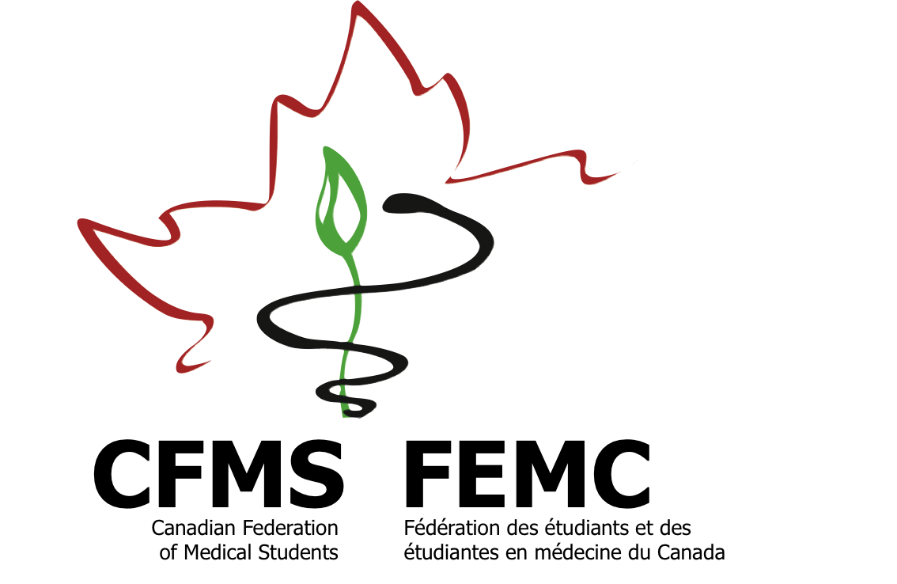

**Canadian Federation of Medical Students**

**Fédération des étudiants et des étudiantes en médecine du Canada**

**www.cfms.org**

**Pharmacare in Canada**

***Improving Access to Medicines for all Canadians***

Canada is the only developed nation in the world with universal healthcare and no corresponding universal pharmaceutical coverage. We are left with a system where outpatient pharmaceutical costs are covered by public, private, and out-of-pocket sources. This fragmented system has caused significant financial problems. Canada's annual rise in prescription drug expenditures **is rising** faster than other countries in the Organisation for Economic Co-operation and Development (OECD) at greater than 6.9%. Furthermore, **Canada's medication prices are amongst the highest in the world - approximately 30% above the OECD average**. Due to the relatively low proportion of public funding for pharmaceutical expenses, these costs come from the pockets of our patients.

These financial burdens have become health burdens. **Approximately 10% of Canadians cannot afford their prescribed medications**. This inability to pay for medications is highest amongst those without private insurance, which constitutes about 23% of Canadians.

**Executive Summary**

A wealth of research has suggested **that** a **national pharmacare plan can address our financial inefficiencies and health inequities.** When accounting for competitive pricing from bulk purchasing, reduced tax deductions, and other improvements, **the estimated savings increase to approximately $11 billion**. This large figure does not include the health and social benefits that would result when Canadians are able to obtain medically necessary treatments for their health conditions.

**The Canadian Federation of Medical Students recognizes that meaningful changes to our pharmaceutical system requires thoughtful analysis and planning in order to make the best use of limited resources. Therefore, the CFMS calls upon the Government of Canada to:**

1. **Establish a concrete plan and corresponding timeline for the exploration of how to create a national formulary, as a first step towards a national pharmacare program;**
2. **Demonstrate continued collaboration with provinces and various stakeholder groups and consider of evidence-based reports when evaluating how to improve access to pharmaceutical care for all Canadians;**
3. **Work with pertinent stakeholder groups to ensure that this national formulary also has the capacity to develop and disseminate guidance about safe and appropriate prescribing practices.**

Elements of an economically and socially effective pharmacare system may include the following:

1. Ensures universal coverage for medically necessary medications with limited patient charge.
2. Integrates financing for medications with financing for other medically necessary services covered under the Canada Health Act.
3. Adequately consolidates purchasing power to ensure the lowest possible drug prices.
4. Works from a National Drug Formulary developed based on sound scientific evidence to ensure the best value-for-money for prescriptions.

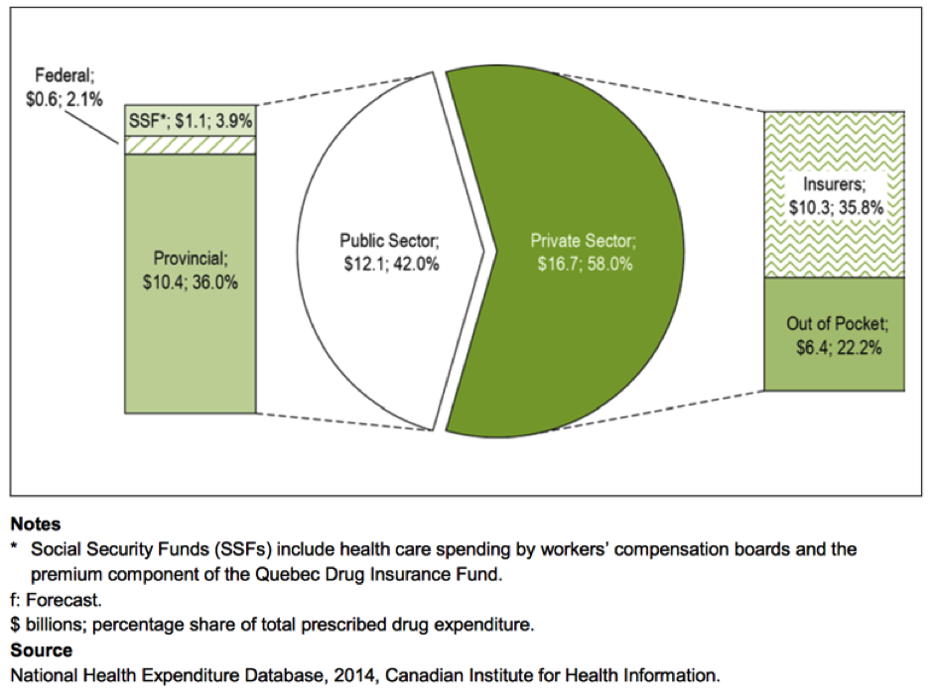The original intent of the Canada Health Act was to implement incremental change leading to a truly universal healthcare system, with the plan to introduce hospital care and medical services followed by prescription drugs and home care1. While hospital care and medical services are provided to Canadians, there have been financial, political, and logistical barriers to funding prescription medicines.

**Background**

In 2014, prescribed medications cost Canadians $28.8 billion, of which $12.1 billion (42.0%) were financed by the public sector3. This leaves $10.3 billion (35.8%) that were supplied by private insurers and $6.4 billion (22.2%) that were paid out-of-pocket by Canadian households3.

In a 2015 survey of the attitudes of Canadians towards access to pharmaceuticals, almost **9 in 10 expressed support for the right of every Canadian to access necessary prescription medications, regardless of income**2. The same proportion of Canadians support the concept of a national pharmacare program that would ensure universal access to prescription medications2.

**Problems with the Current Pharmaceutical System**

**Financial**

* ***A fragmented pharmaceutical coverage system decreases bargaining power.***In Canada, our fragmented system decreases our purchasing power as the provincial governments must negotiate with the pharmaceutical companies separately. Due to differences in bargaining power, smaller provinces tend to pay more than larger provinces for the same medications1. The percentage of households that spend greater than 5% of income on prescription medications varies widely between provinces, ranging from only 2.2% in Ontario to 10.1% in Prince Edward Island4.
* ***Reliance on private insurance leads to higher premiums and administrative costs****.* Insurance companies managing private drug plans are compensated by the premiums paid on those plans. In Canada's public Medicare system, just 1.3% of total spending is devoted to administrative costs compared to 13% in private plans (Woolhandler et al., 2003).
* ***Public investment in pharmaceutical R&D in Canada does not result in good return-on-investment****.* Canadian intellectual property law currently provides 20 years of patent protection for pharmaceutical products that come to market in Canada. This has contributed to a dramatic increase in the costs of pharmaceutical products and represents a significant investment in pharmaceutical research and development (R&D) that has not paid the expected dividends (Canadian Health Coalition, 2007).

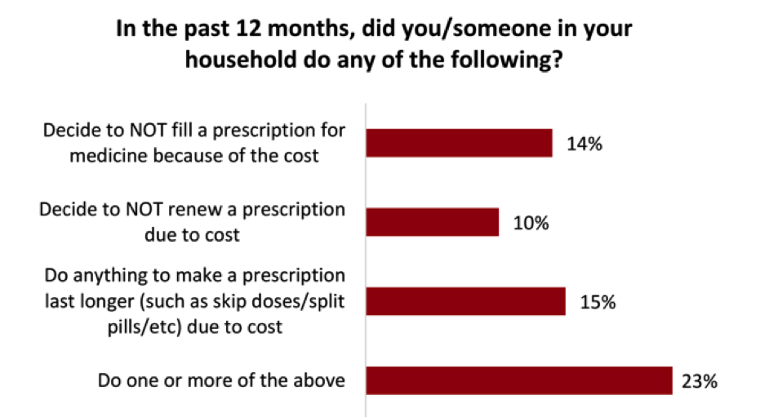**Health**

* ***Access to pharmaceuticals.***The Canada Health Act mandates universal, accessible and comprehensive healthcare for all Canadians, yet a significant portion of Canadians still report difficulty in accessing necessary prescription medications.
* ***Health equity****.* There is a clear association between household income and likelihood of cost-related prescription non-adherence. Approximately 1 in 5 Canadians with an annual household income of less than $20,000 report some form of prescription non-adherence, compared to just 1 in 20 Canadians with an annual household income of greater than $80,000 (Law et al., 2012).

**Financial**

**Benefits to Universal Pharmaceutical Coverage**

* ***Increasing Purchasing Power.*** Buying in bulk secures the lowest prices for medications. With the federal government joining the pan-Canadian Pharmaceutical Alliance, we should see an increase from the already established savings of $260 million **annually10.**
* ***Eliminating the Inefficiencies of the Private Insurance Market.*** Administrative costs of private health insurance are approximately 10 times higher than public administration1. A single-payer system would save $1.35 billion annually from administrative efficiency and decreased advertising6.
* ***Rational Health System Decision-Making.*** Incorporating financing for medications into financing for other medically necessary health care and developing a national drug formulary based on sound scientific evidence will lead to a rational approach to health care spending.
* ***Safety and Efficacy.*** A National Drug Formulary tied to a national body tasked to evaluate medications based on safety, efficacy, and cost-effectiveness would ensure standardization across provinces, which currently each develop their own formularies. Developing a national formulary is a logical extension of the Common Drug Review process.

**Health and Social**

* ***Promoting Access to Necessary Medicines.*** Patients who live in nations with low out-of-pocket **health care** expenses are more likely to take their medication1.
* ***Ensuring Financial Protection and Equity.*** Over 5% of Canadians pay more than $1000 USD out-of-pocket annually for prescription medications1. This decreases funding available for preventative health maintenance such as healthy eating and regular physical activity.

1Morgan, S.G., Daw, J.R., Law, M.R. (2013). Rethinking Pharmacare in Canada. Toronto, ON: C.D. Howe Institute. Retrieved from: https://www.cdhowe.org/pdf/Commentary_384.pdf

#### **References**

2Angus Reid Institute. (2015). *Prescription drug access and affordability an issue for nearly a quarter of all Canadian households.* Vancouver, BC: Angus Reid Institute for Public Interest Research. Retrieved from: http://angusreid.org/

3Canadian Institute for Health Information. (2015). *Prescribed Drug Spending in Canada, 2013: A Focus on Public Drug Programs*. Ottawa, ON: Canadian Institute of Health Information. Retrieved from: <https://secure.cihi.ca/free_products/Prescribed_Drug_Spending_in_Canada_EN.pdf>

4Statistics Canada (2006) Survey of Household Spending 2006.

5Law, M.R., Cheng, L., Dhalla, I.A., Heard, D., & Morgan, S.G. (2012). The effect of cost on adherence to prescription medications in Canada. *Canadian Medical Association Journal,184(*3):297-302.

6Gagnon, M.A. (2014). A roadmap to a rational Pharmacare policy in Canada. Ottawa, ON: The Canadian Federation of Nurses Unions. Retrieved from: https://nursesunions.ca/sites/default/files/pharmacare_report.pdf

|  |  |
| --- | --- |
|  |  |
|  |  |
|  |  |
|  |  |